**Submitted To: Engr. Ammad Khalil**

**Submitted By: Shah Raza (44)**

**Ashiq Ullah (77)**

**Section: B**

**Date: 16/10/2018**

DEPARTMENT OF COMPUTER SYSTEM ENGINEERING, UET, PESHAWAR.

Computer Fundamentals

lab report #2

2018

Table of Contents

**INTRODUCTION TO COMPUTER SOFTWARE AND INSTALLATION OF WINDOWS** 3

**1. SOFTWARE:** 3

**1.1 SYSTEM SOFTWARE:** 3

**1.2 APPLICATION SOFTWARE:** 3

**1.3 UTILITY SOFTWARE:** 3

**2. OPERATING SYSTEM:** 4

**2.1 WINDOWS:** 4

**2.2 UNIX:** 7

**2.3 LINUX:** 7

**3. INSTALLATION OF WINDOWS:** 7

# **INTRODUCTION TO COMPUTER SOFTWARE AND INSTALLATION OF WINDOWS**

# **1. SOFTWARE:**

Software, in its most general sense, is a set of instructions or programs instructing a computer to do specific tasks. Software is a generic term used to describe computer programs. Scripts, applications, programs and a set of instructions are all terms often used to describe software.

There are **THREE** types of software:

## **1.1 SYSTEM SOFTWARE:**

System software is a type of computer program that is designed to run a computer’s hardware and application programs. The operating system (OS) is the best-known example of system software. The OS manages all the other programs in a computer.

## **1.2 APPLICATION SOFTWARE:**

Application software is a subclass of computer software that employs the capabilities of a computer directly and thoroughly to a task that the user wishes to perform. Typical examples of software applications are word processors, spreadsheets, and media players.

## **1.3 UTILITY SOFTWARE:**

Utility software helps to manage, maintain and control computer resources. Examples of utility programs are antivirus software, backup software and disk tools. A device driver is a computer program that controls a particular device that is connected to your computer.

**2. OPERATING SYSTEM:**  An operating system (OS) is the program that, after being initially loaded into the computer by a boot program, manages all the other programs in a computer. The other programs are called *applications* or application programs. The application programs make use of the operating system by making requests for services through a defined application program interface (API). In addition, users can interact directly with the operating system through a user interface such as a command line or a graphical user interface (GUI).

Some of the most common Operating Systems are:

**2.1 WINDOWS:** Windows is Microsoft’s flagship operating system for home and business computers. Introduced in 1985, the GUI-based OS has been released in many versions since then. The user-friendly Windows 95 was largely responsible for the rapid development of personal computing.

**VERSIONS:**

1. **Windows 95** was released on August 24, 1995. Accompanied by an extensive marketing campaign, Windows 95 introduced numerous functions and features that were featured in later Windows versions, such as the taskbar, the "Start" button and the ways the user could navigate.

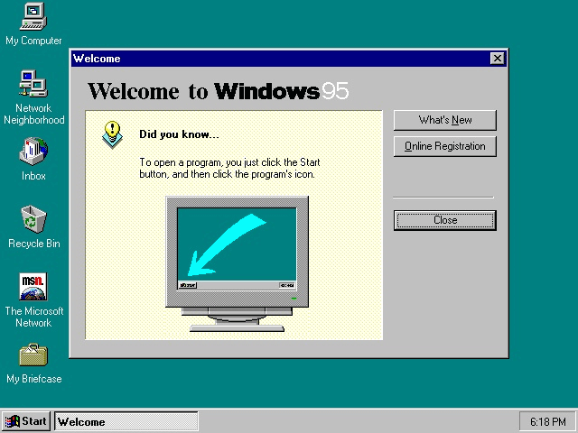

1. **Windows XP** is a personal computer operating system produced by Microsoft as part of the Windows NT family of operating systems. It was released to manufacturing on August 24, 2001, and broadly released for retail sale on October 25, 2001.

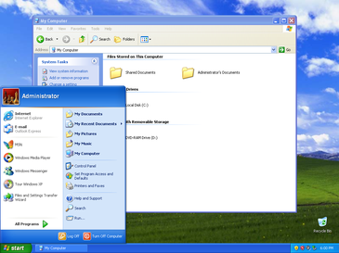

1. **Windows 7** is a personal computer operating system that was produced by Microsoft as part of the Windows NT family of operating systems. It was released to manufacturing on July 22, 2009 and became generally available on October 22, 2009.

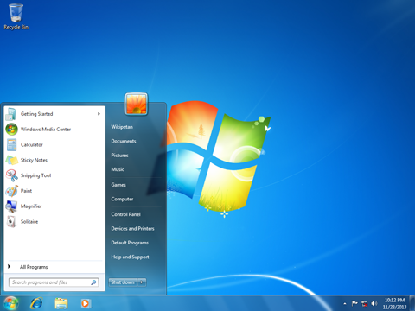

1. **Windows 8** introduced major changes to the operating system's platform and user interface to improve its user experience on tablets, where Windows was now competing with mobile operating systems, including Android and iOS.

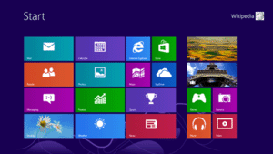

1. **Windows 10** was released on July 29, 2015.One of Windows 10's most notable features is support for universal apps, an expansion of the Metro-style apps first introduced in Windows 8. Universal apps can be designed to run across multiple Microsoft product families with nearly identical code‍—‌including PCs, tablets, smartphones, embedded systems, Xbox One, Surface Hub and Mixed Reality.

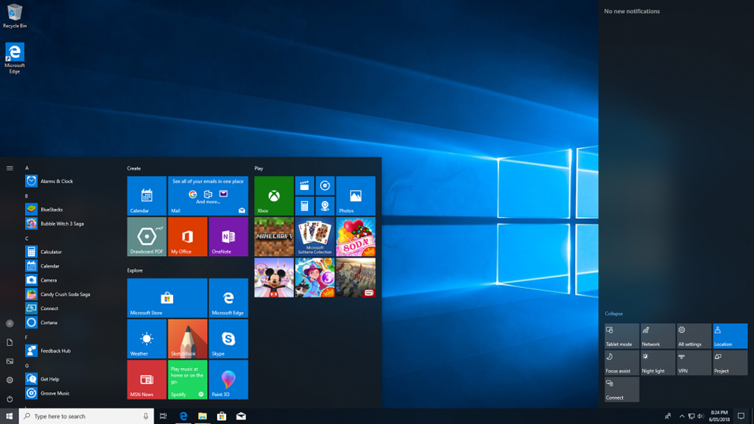

**2.2 UNIX:**  Unix is a proprietary software operating system. It was developed by Bell Labs for its own use but over the years was licensed to other tech companies. The Unix OS works primarily on Command Line Interface, though, recently, there have been developments for GUI on Unix systems. Unix is not free. Different flavors of Unix have different cost structures according to vendors. Unix is a proprietary operating system commonly used in internet servers, workstations and PCs by Solaris, Intel, HP etc.

**2.3 LINUX:** Linux is a very flexible operating system and is compatible with most hardware systems. Linux OS can be installed and executed on almost anything that has a processor. Linux is an open source, free to use operating system widely used for computer hardware and software, game development, tablet PCS and mainframes.

# **3. INSTALLATION OF WINDOWS:**

**STEP 1:**  Format the drive and set the primary partition as active.

**STEP 2:** Connect a USB flash drive to your PC.

**STEP 3:** Open Disk Management: Start > Settings: Create and format hard disk partitions*.*

**STEP 4:** Format the partition: Right-click the USB drive partition > Format. Select the FAT32 file system to be able to boot either BIOS-based or UEFI-based PCs.

**STEP 5:** Set the partition as active: Right-click the USB drive partition > Mark Partition as Active*.*

**STEP 6:**  Copy Windows Setup to the USB flash drive.

**STEP 7:** Copy and paste the entire contents of the Windows product DVD to the USB flash drive*.*

**STEP 8: Optional**: add an Unattended file or a configuration set to automate the installation process. For more information, see Automate Windows Setup*.*

**STEP 9:**  Install Windows to the new PC.

**STEP 10:** Connect the USB flash drive to a new PC.

**STEP 11:**  Turn on the PC and press the key that opens the boot-device selection menu for the computer, such as the Esc key. Select the option that boots the PC from the USB flash drive.

**STEP 12:**  Windows Setup starts. Follow the instructions to install Windows.

**STEP 13:** Remove the USB flash drive.